Items for Loan from Outreach
Each could be used for a program, in daily library routines, or for specific patrons. Any creative usage is welcomed as well.

Civics Kit – DVD, manual, questions to help persons seeking USA citizenship or to help communities understand the process others have to go through
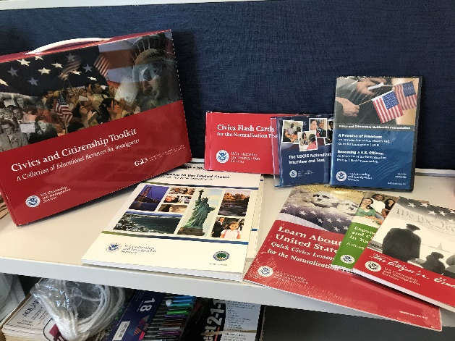

Craft Lights (2) – Plug in lights. Programs in low lighting rooms or a spot light for Storytime’s

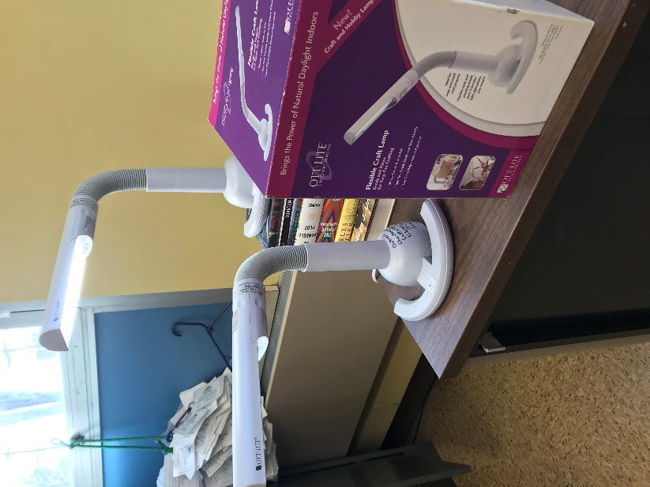

Magnifier – Handheld, backlight magnifier

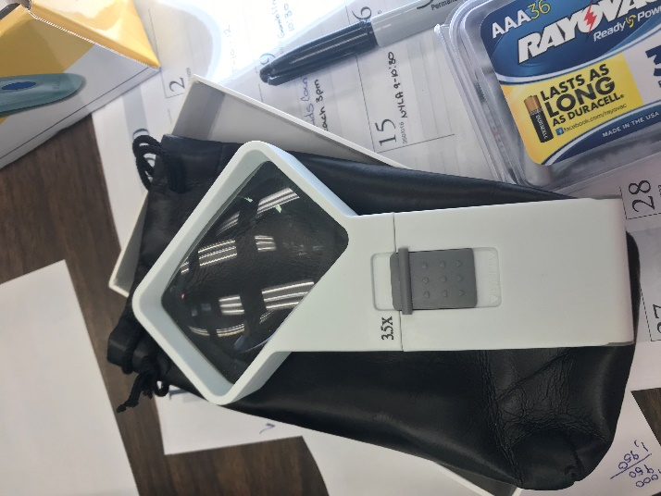

Banner (2) and Table Cloth (2) – Use when out in the community at events or promoting your library
