Census 2020 Quick Facts
Dates: March 12th – July 31st 2020 self-reporting
Ways to take the survey:
- Online- www.2020Census.gov (official survey site will be live March 12)
- By Phone- 844-330-2020 for English 844-468-2020 for Spanish
- Paper Survey- Mailed directly to address (you can wait for it to come)
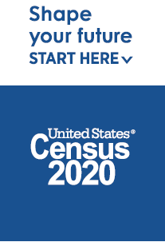
Can the library get a blank paper survey: No
There is NO Census APP
The Census will not e-mail or text for any reason

Census 2020 Quick Facts
Dates: March 12th – July 31st 2020 self-reporting
Ways to take the survey:
- Online- www.2020Census.gov (official survey site will be live March 12)
- By Phone- 844-330-2020 for English 844-468-2020 for Spanish
- Paper Survey- Mailed directly to address (you can wait for it to come)
Can the library get a blank paper survey: No
There is NO Census APP
The Census will not e-mail or text for any reason

