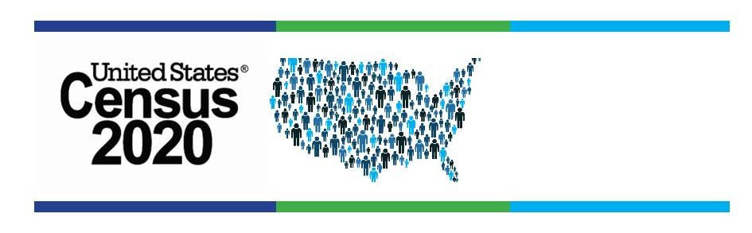

Know Your 2020 Census Fast Facts Game:

1. What does Internet Choice mean? A household will be mailed an online invitation and a paper copy

2. To whom can the Census Bureau give your No one, no business, no
specific information? government agency

3. Who fills out the Census? One person in each household

4. Name one reason you need to be counted? Representation in Congress
Allocation of federal funds

5. What is the first day you can self-report? Mar. 12th

6. Can a person get a paper copy from No
the library?

7. What is Question 1 on the survey? How many people are living in
your house on April 1?

8. What are the 3 ways to fill out the Census? Online, paper, phone

9. What happens if a person does not fill out Paper copy will be mailed, an the Census online? enumerator will visit the home

10. Who in your library needs to know this Everyone! Director, staff, & Census information? volunteers

