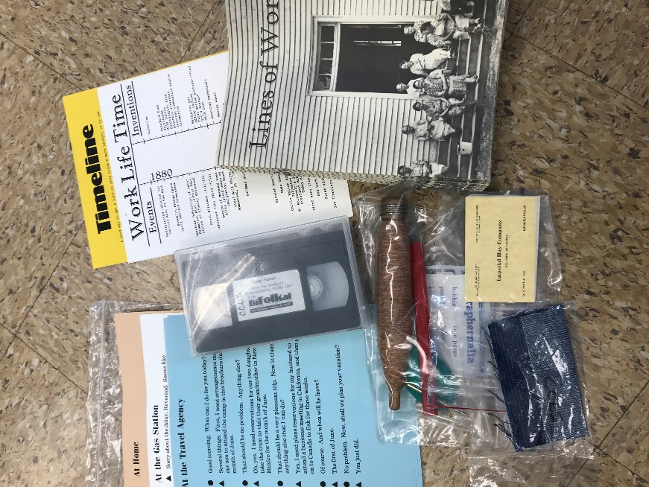
Work Life Bifolkal Kit
Contents:
- 1 Vinyl Bag
- 1 Program Manual
- 23 Song books
- Scripts for Skits ( 3 skits)
- Theme Related Items for Discussion (6)
- Video tape “ Many Hands”

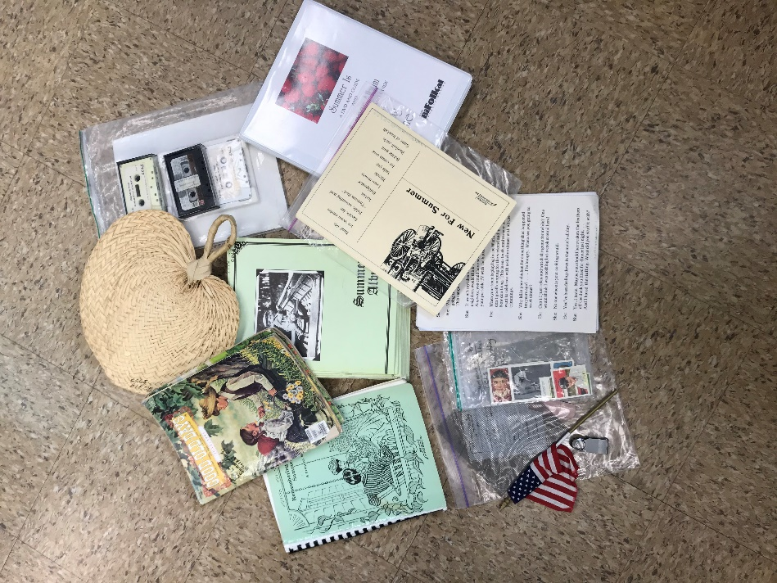
Summertime Bifokal Kit
Contents:
- 1 Vinyl Bag
- 1 Program Manual
- 22 Song Books
- 1 DVD guide with CD (songs) guide
- Cassette Tapes with Songs
- Theme related items for discussion
- 3 Good Old Day Magazines
- Scrips for Skit

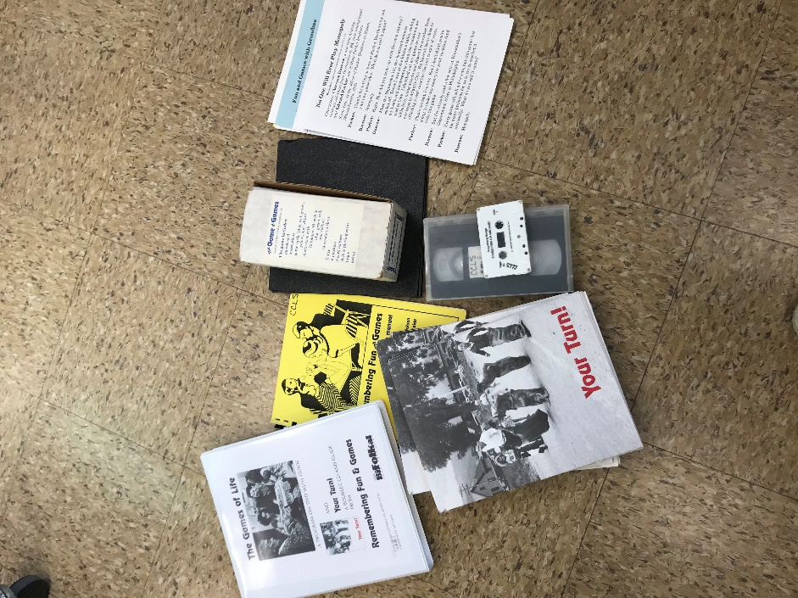
Fun and Games Bifolkal Kit
Contents:
- 1 Vinyl Bag
- 1 Program Manual
- 25 Song books
- 1 DVD with CD (songs) guide and booklet
- Videotape “Games of Life”
- Cassette with songs
- 2 Scripts for skits
- Box with games
- Theme related items for discussion

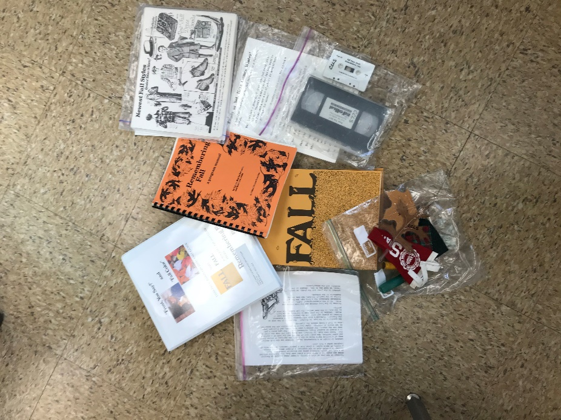
Fall Bifolkal Kit
Contents:
- 1 Vinyl Bag
- 1 Program Manual
- 25 Song Books
- DVD with CD (songs) Guide
- Video Tape “Frost You say”
- Cassette of Songs
- Script for Skits
- Theme Related items for discussion

Pets Bifolkal Kit
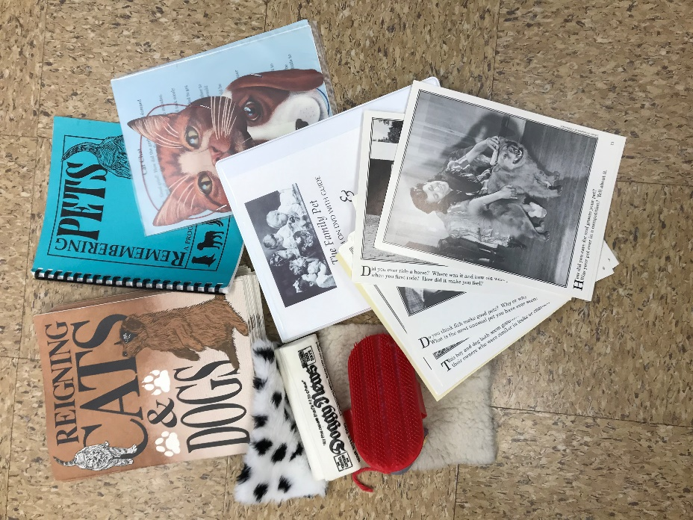
Contents:
- 1 Vinyl Bag
- 1 Program Manual
- 25 Song Books
- DVD with CD (songs) Guide
- Video Tape “The Family Pet”
- Cassette of Songs
- Script for Skits
- Theme Related items for discussion

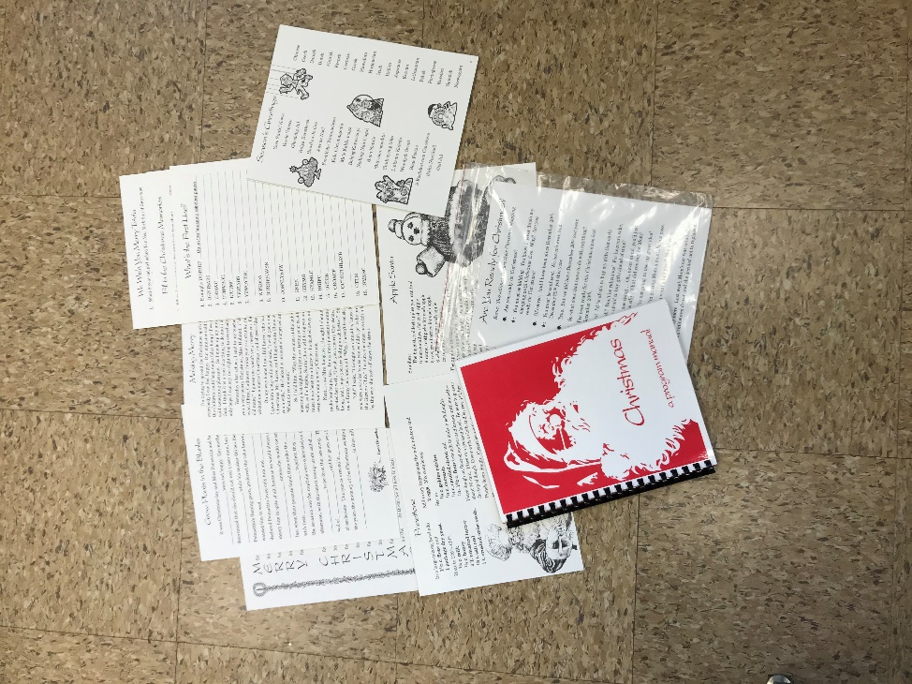
Christmas Bifolkal Mini-Kit
Contents:
- 1 Red Bag
- 1 Program Manual
- Video Tape – “Open for Christmas”
- Script for Skit
- Christmas Activates in Red Folder

Fifties BiFolkal Kit
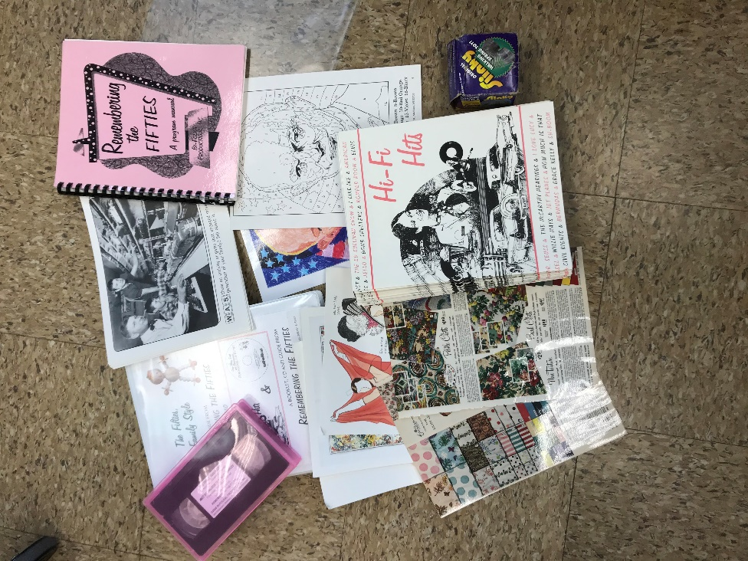
Contents:
- 1 Vinyl Bag
- 1 Program Manual
- 23 Song Books
- DVD with CD (songs) Guide
- Video Tape “The fifties, Family Style”
- Theme Related items for discussion
- Fifties Actives in Blue folder
- Color by Number “Ike”

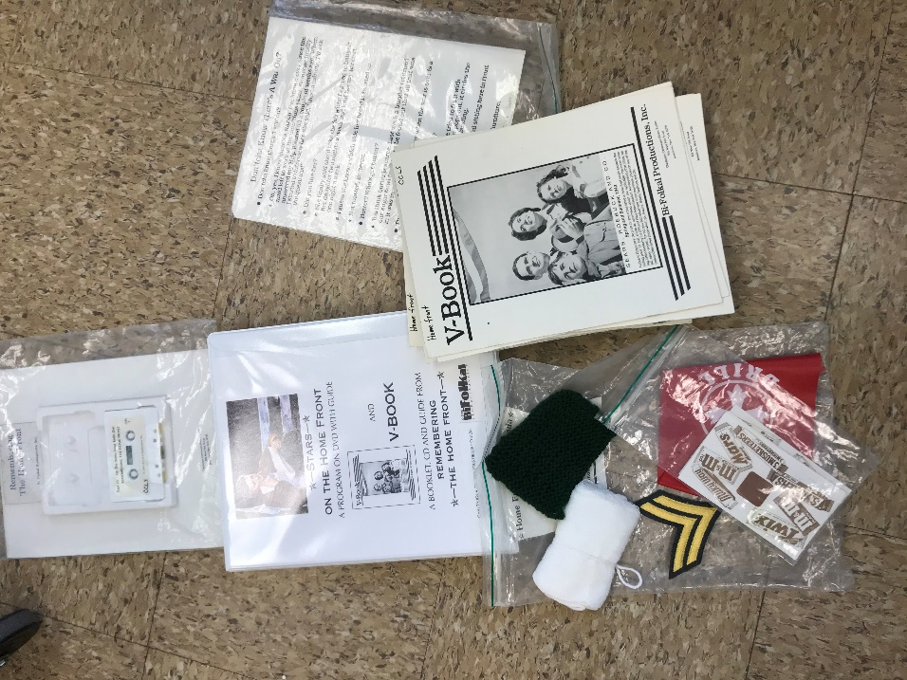
Home Front Bifolkal Kit
Contents:
- 1 Vinyl Bag
- 1 Program Manual
- 23 Song Books
- DVD with CD (songs) Guide
- Script for skit
- Cassette Tape of songs
- Theme Related items for discussion

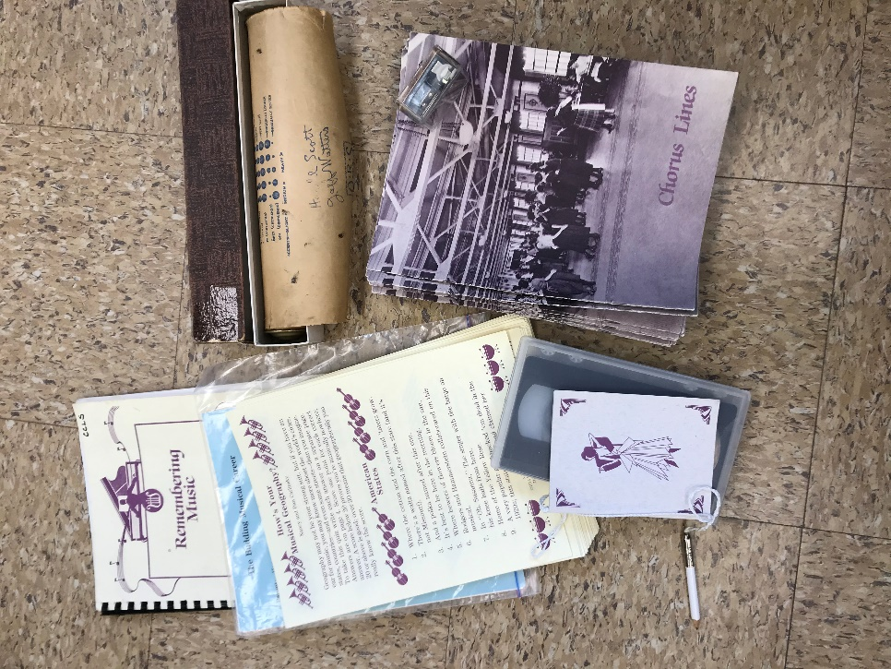
Music Bifolkal Kit
Contents:
- 1 Vinyl Bag
- 1 Program Manual
- 23 Song Books
- Script for skit
- Video Tape – “Keeping Time”
- Theme Related items for discussion

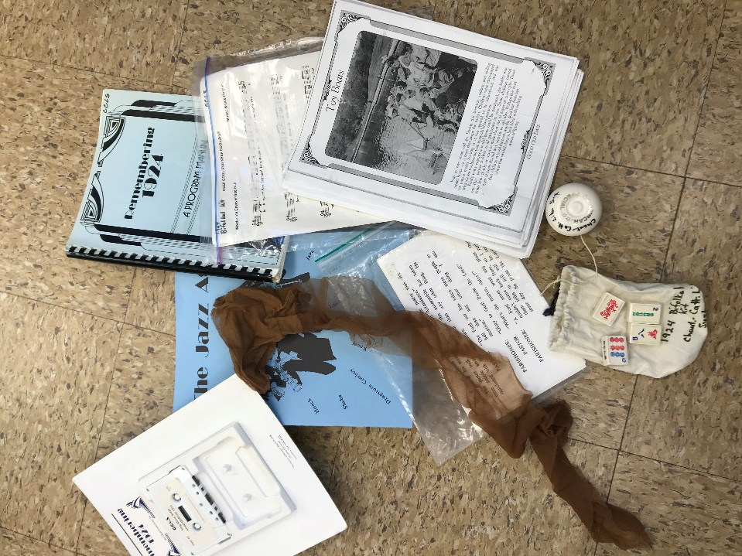
1924 Bifolkal Kit
- 1 Vinyl Bag
- 1 Program Manual
- 25 Song Books
- Crossword Puzzle
- Cassette of Songs
- Theme Related items for discussion

Home Bifolkal Kit
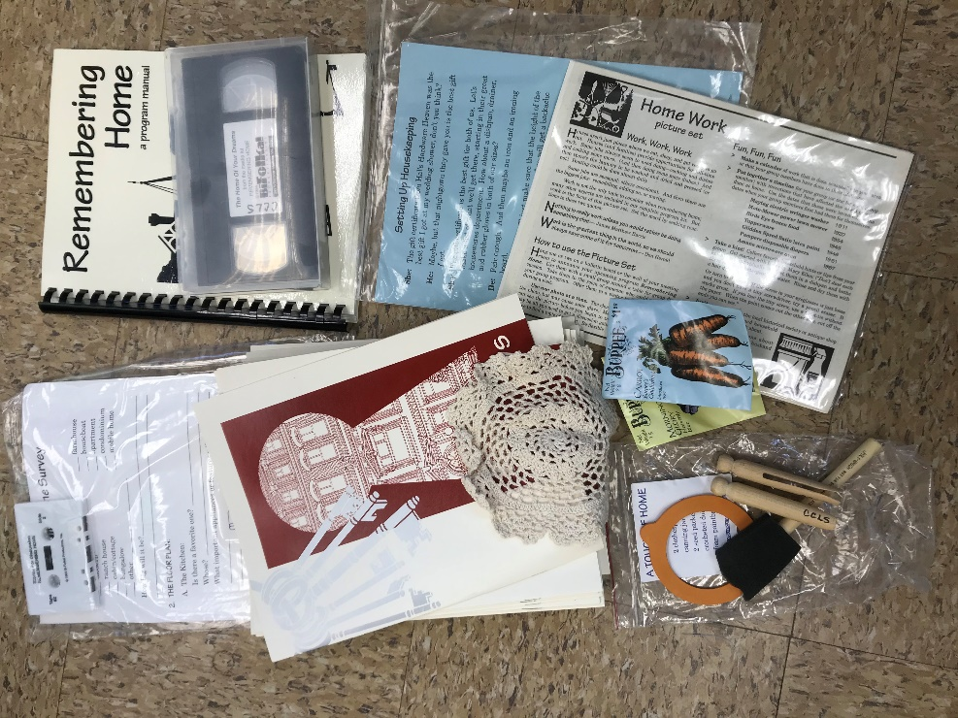
Contents:
- 1 Vinyl Bag
- 1 Program Manual
- 25 Song Books
- Video Tape “The Home of your Dreams”
- Cassette of Songs
- Theme Related items for discussion

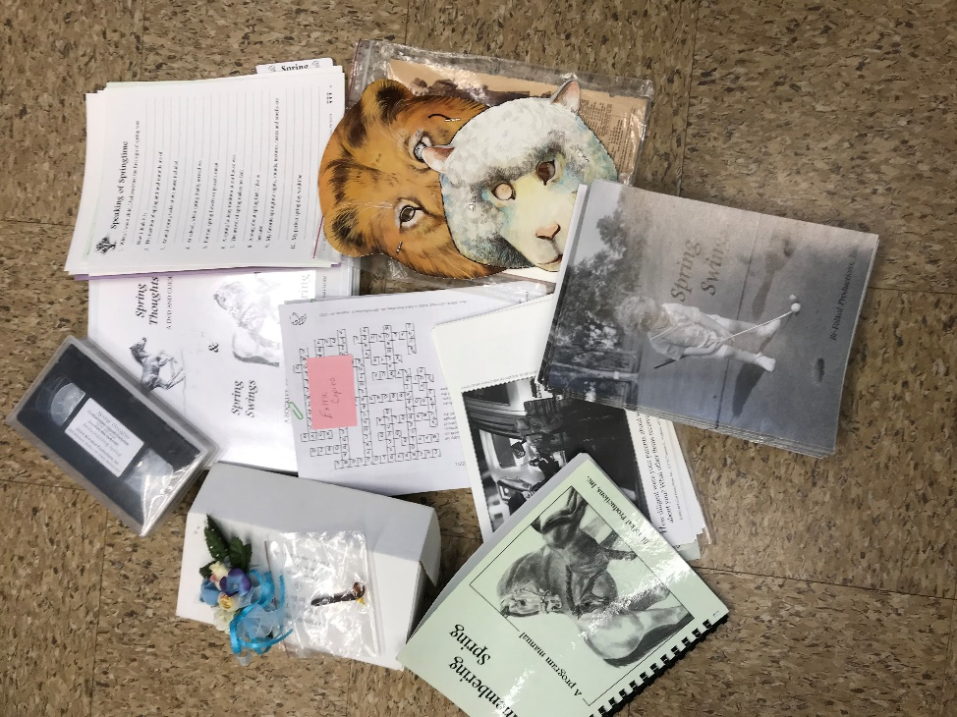
Spring Bifolkal Kit
Contents:
- 1 Vinyl Bag
- 1 Program Manual
- 25 Song Books
- DVD with CD (songs) Guide
- Video Tape
- Activities in Purple Folder
- Theme Related items for discussion

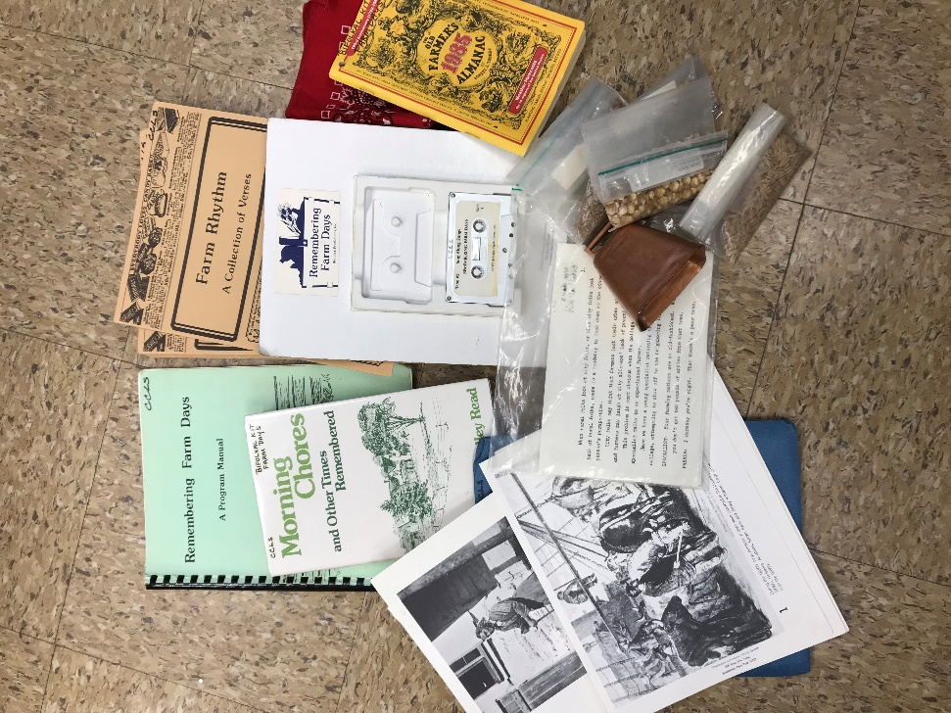
Farm Days Bifolkal Kit
Contents:
- 1 Vinyl Bag
- 1 Program Manual
- 24 Song Books
- Cassette of Songs
- Book of farm poems
- Pictures in Blue Folder
- Theme Related items for discussion

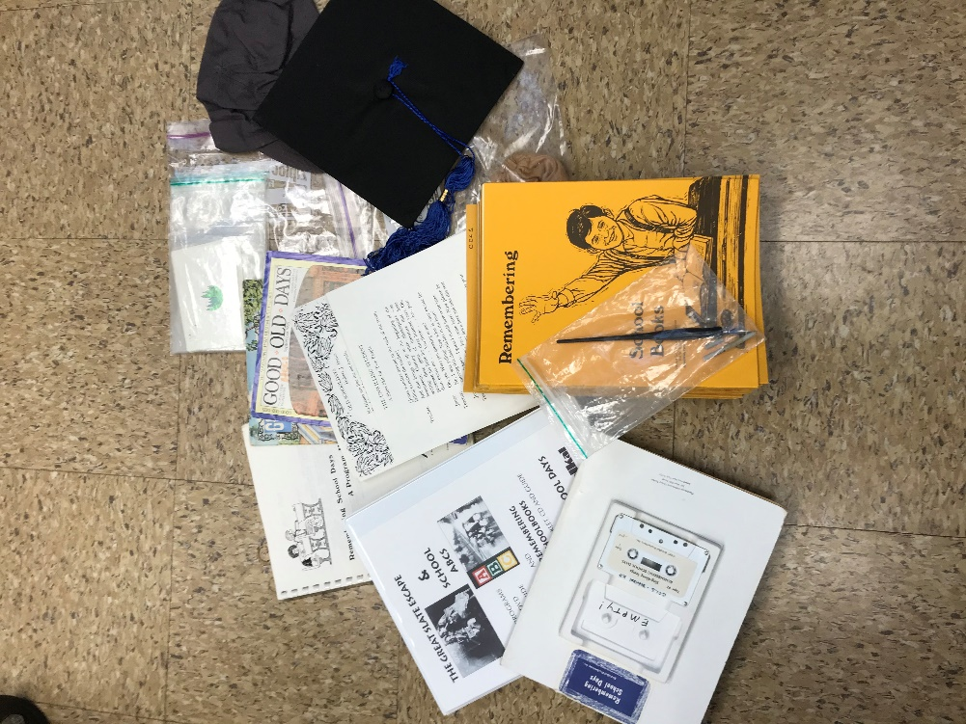
School Days Bifolkal Kit
Contents:
- 1 Vinyl Bag
- 1 Program Manual
- 25 Song Books
- DVD with CD (songs) Guide
- Cassette of Songs
- Script for skits
- Theme Related items for discussion

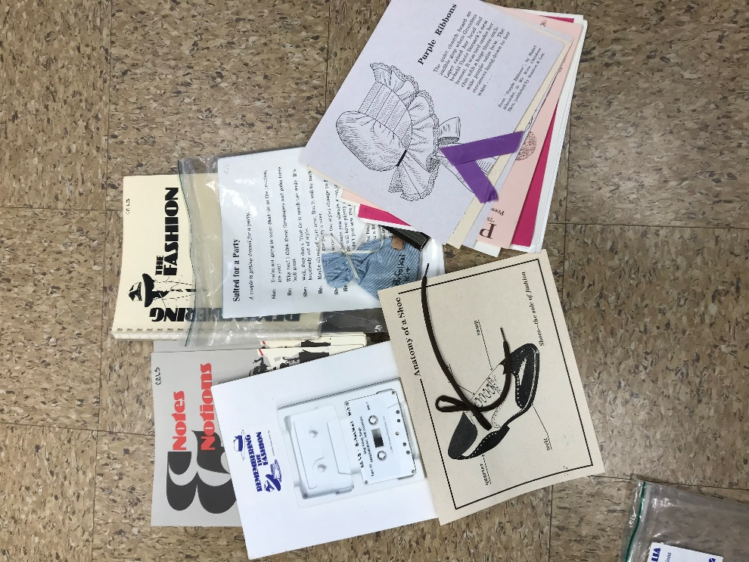
Fashion Bifolkal Kit
Contents:
- 1 Vinyl Bag
- 1 Program Manual
- 24 Song Books
- Cassette of Songs
- Script for skits
- Theme Related items for discussion

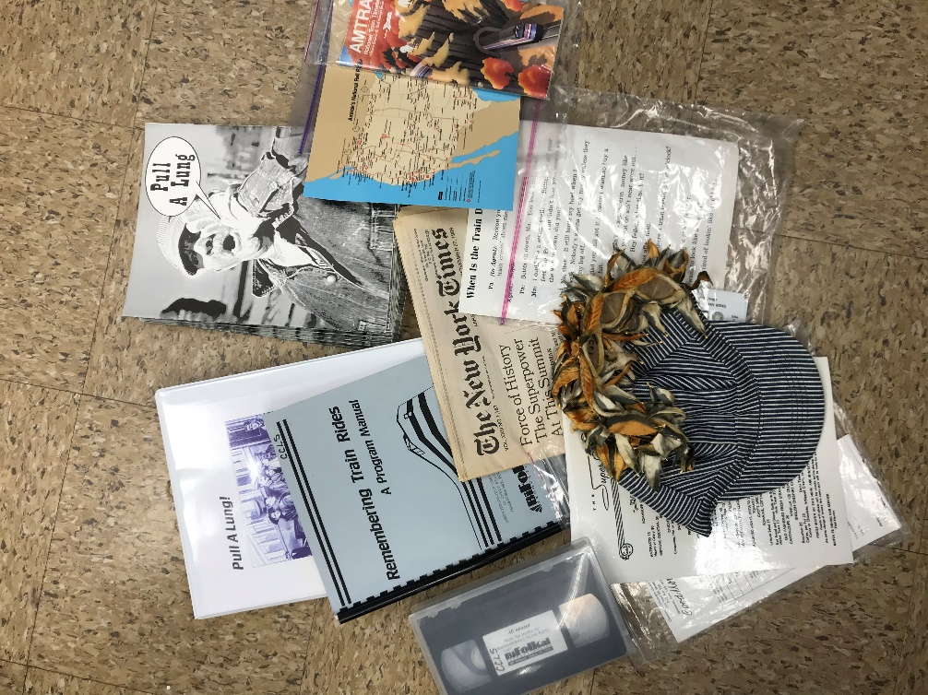
Train Rides Bifolkal Kit
Contents:
- 1 Vinyl Bag
- 1 Program Manual
- 24 Song Books
- DVD with CD (songs) Guide
- Cassette of Songs
- Video “All Aboard”
- Script for skits
- Maps
- Theme Related items for discussion

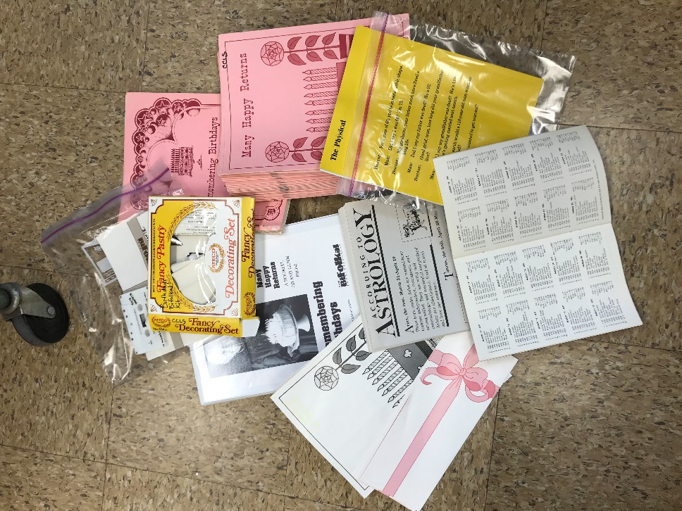
Birthdays Bifolkal Kit
Contents:
- 1 Vinyl Bag
- 1 Program Manual
- 24 Song Books
- DVD with CD (songs) Guide
- Cassette of Songs
- Book of famous birthdays
- Script for skits
- Theme Related items for discussion

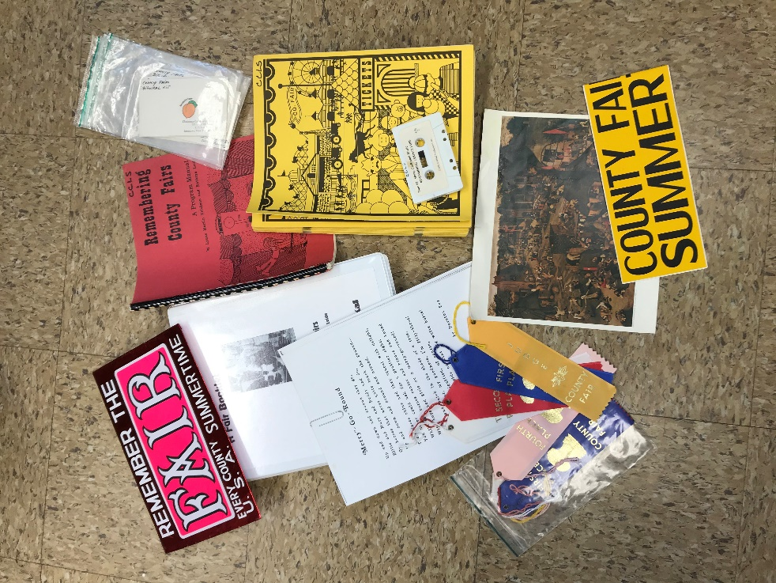
County Fair Bifolkal Kit
Contents:
- 1 Vinyl Bag
- 1 Program Manual
- 24 Song Books
- DVD with CD (songs) Guide
- Cassette of Songs
- Script for skits
- Theme Related items for discussion

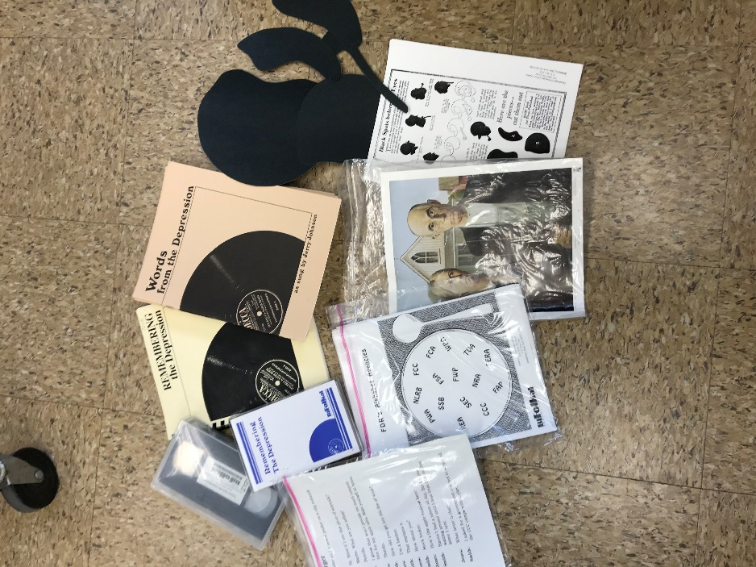
Depression Bifolkal Kit
Contents
- 1 Vinyl Bag
- 1 Program Manual
- 24 Song Books
- Cassette of Songs
- Script for skits
- Shapes creating people activity
- Theme Related items for discussion

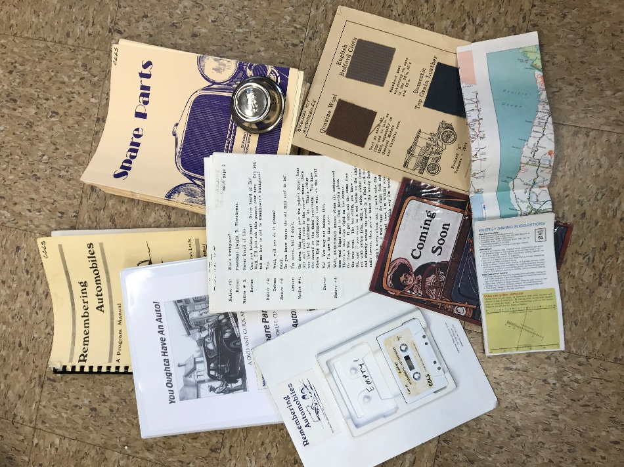
Automobiles Bifolkal Kit
Contents
- 1 Vinyl Bag
- 1 Program Manual
- 24 Song Books
- DVD with CD (songs) Guide
- Cassette of Songs
- Script for skits
- Theme Related items for discussion

African American Lives Bifolkal
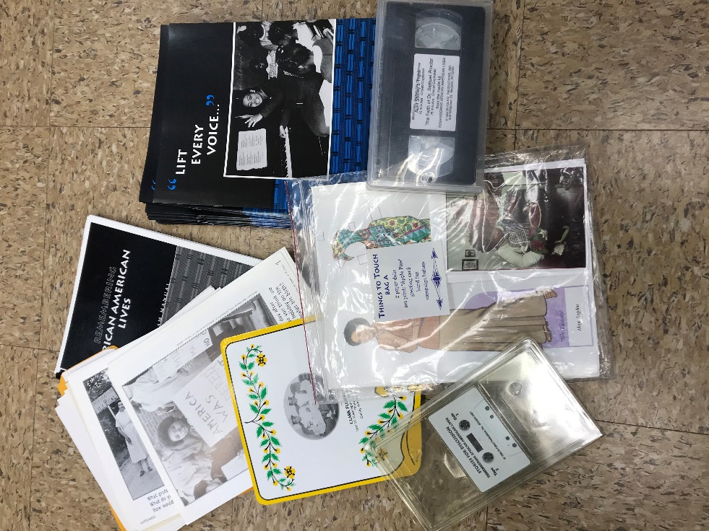
Contents
- 1 Vinyl Bag
- 1 Program Manual
- 24 Song Books
- Video
- Cassette of Songs
- Pictures Activities in orange folder
- Theme Related items for discussion

BiFolkal Kits
CCLS has 20 kits available for check out. Each kit has a different theme and the aim is to help start conversations around that theme. These kits were developed by librarians with the goal of helping our older generations remember stories from their past.
Each kit has a program manual, song books, and activities to do. Some kits have DVD’s and CD while others only have Video Taps and Cassettes. The follow list has a general list of what is in each kit.
The program manual is a guide only, and each kit can have different actives depending on the audience or resources. You can be as creative or follow along with the program, or only use part of the kit.

We are looking for a few partners to check out a kit or two and provide feedback as well. These are great resources, but all feedback is valuable as times change. If you are interested, email or call Jackie at CCLS and we will send the kit out in the next deposit collection.

All the best for 2021!
LJ Martin
CCLS Outreach Coordinator

